LAB NO 9: Quiz

Scenario: Online Food Delivery

- Create a database
CREATE DATABASE FoodDeliveryDB;
USE FoodDeliveryDB;

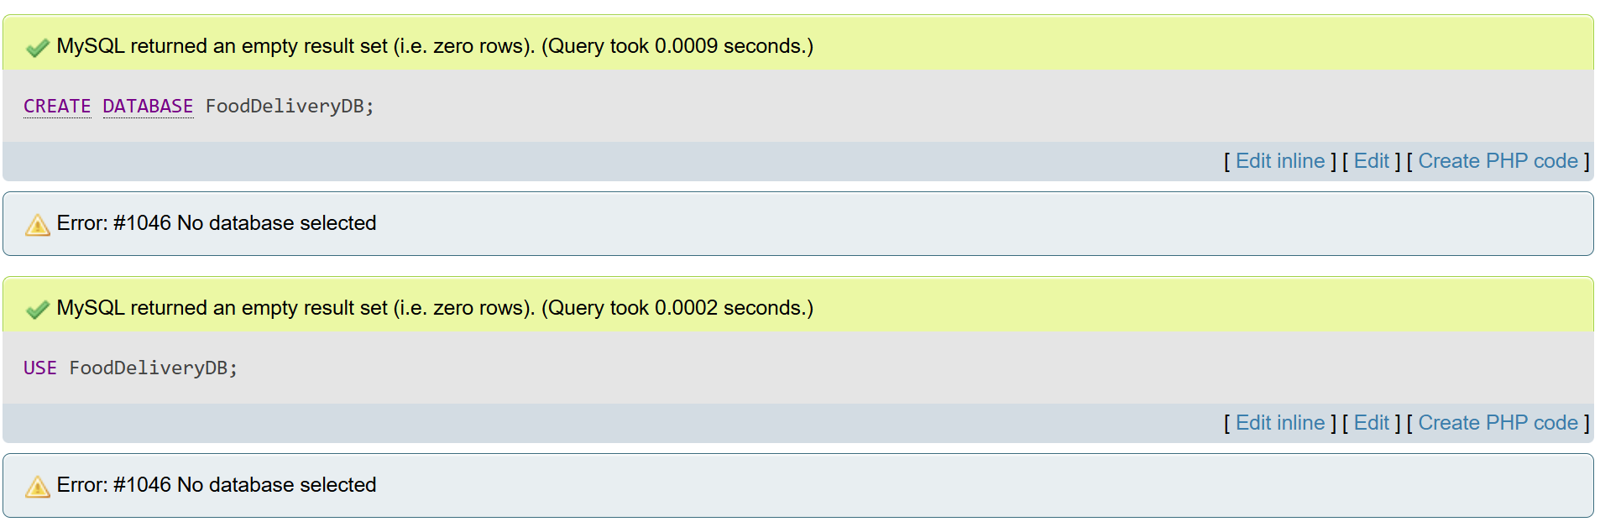

- Create a table
CREATE TABLE Orders (
OrderID INT PRIMARY KEY,
CustomerName VARCHAR(100),
FoodItem VARCHAR(100),
Quantity INT CHECK (Quantity > 0),
OrderDate DATE,
DeliveryStatus VARCHAR(50) DEFAULT 'Pending'
);
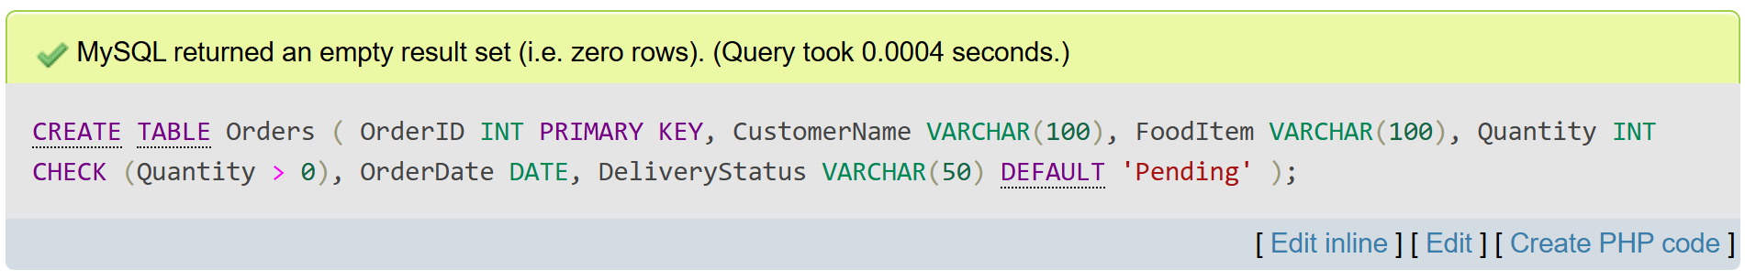

- Show all databases and show tables inside FoodDeliveryDB
SHOW DATABASES;
USE FoodDeliveryDB;
SHOW TABLES;
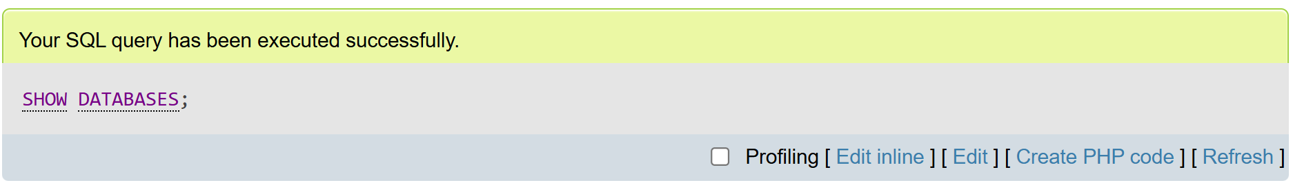
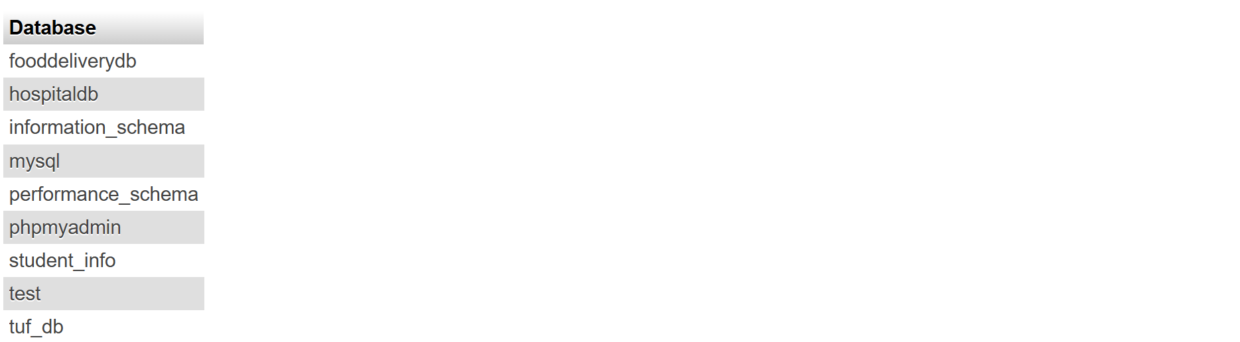
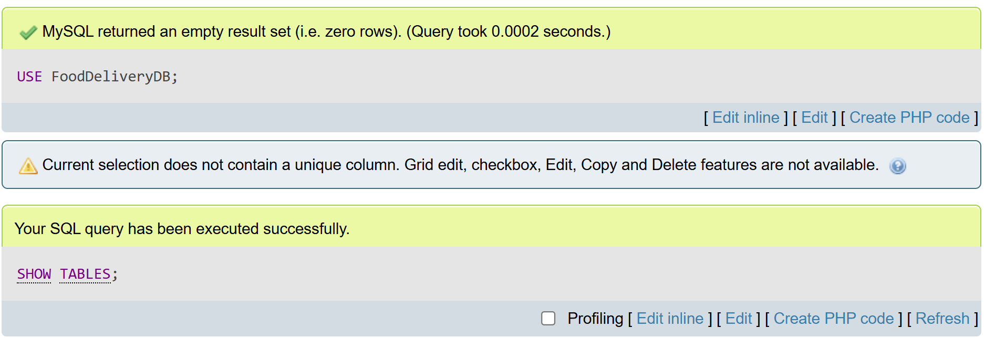

- Add a new column
ALTER TABLE Orders ADD TotalPrice DECIMAL(10, 2);
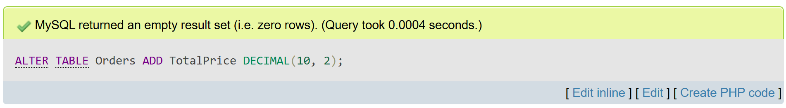

- Insert ten food order records
INSERT INTO Orders (OrderID, CustomerName, FoodItem, Quantity, OrderDate, DeliveryStatus, TotalPrice) VALUES
(201, 'Ali', 'Burger', 2, '2025-05-10', 'Pending', 500.00),
(202, 'Sara', 'Pizza', 1, '2025-05-11', 'Pending', 800.00),
(203, 'Zain', 'Biryani', 3, '2025-05-11', 'Pending', 750.00),
(204, 'Areeba', 'Pasta', 2, '2025-05-12', 'Pending', 600.00),
(205, 'Hassan', 'Sandwich', 1, '2025-05-12', 'Pending', 300.00),
(206, 'Tariq', 'Nuggets', 4, '2025-05-12', 'Pending', 900.00),
(207, 'Noor', 'Burger', 2, '2025-05-13', 'Pending', 500.00),
(208, 'Fahad', 'Fries', 1, '2025-05-13', 'Pending', 200.00),
(209, 'Lubna', 'Pizza', 2, '2025-05-13', 'Pending', 1600.00),
(210, 'Asad', 'Biryani', 5, '2025-05-13', 'Pending', 1250.00);
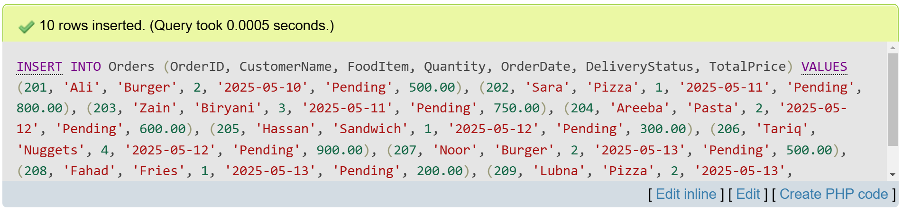

- Update the delivery status
UPDATE Orders
SET DeliveryStatus = 'Delivered'
WHERE OrderID = 202;
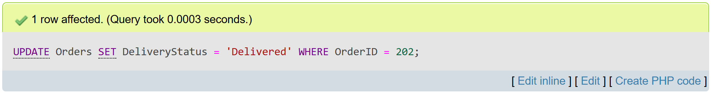

- Delete any orders where the quantity is greater than 3
DELETE FROM Orders
WHERE Quantity > 3;
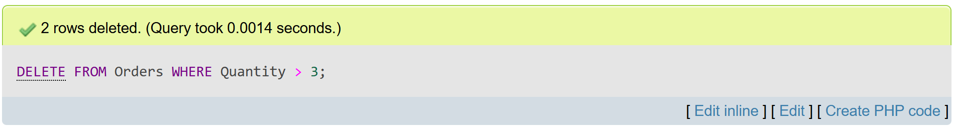
- Select and display all delivered orders
SELECT *
FROM Orders
WHERE DeliveryStatus = 'Delivered'
ORDER BY TotalPrice DESC;
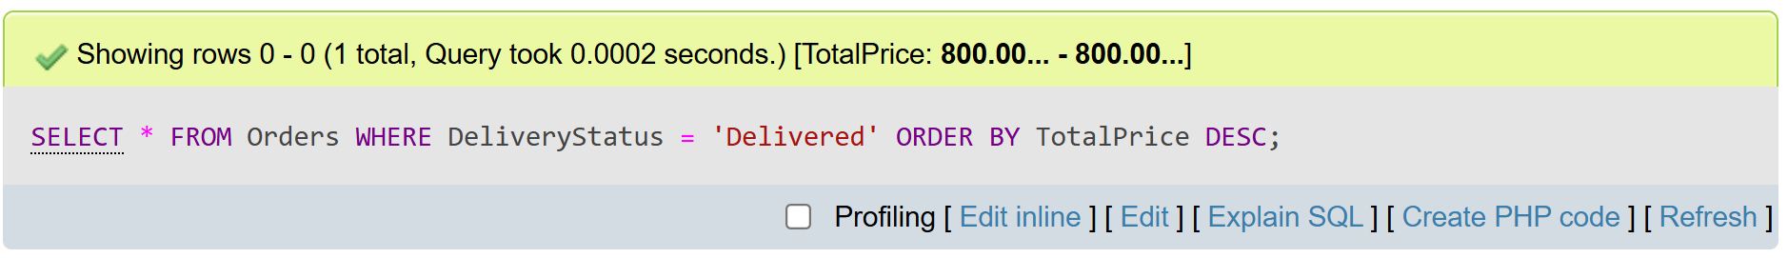
- Drop the Orders table
DROP TABLE Orders;
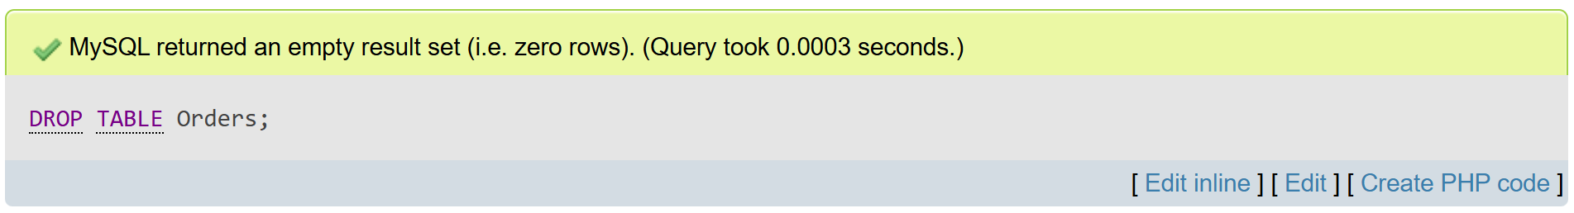

Scenario: Hospital Management
- Create a database
CREATE DATABASE HospitalDB;
USE HospitalDB;
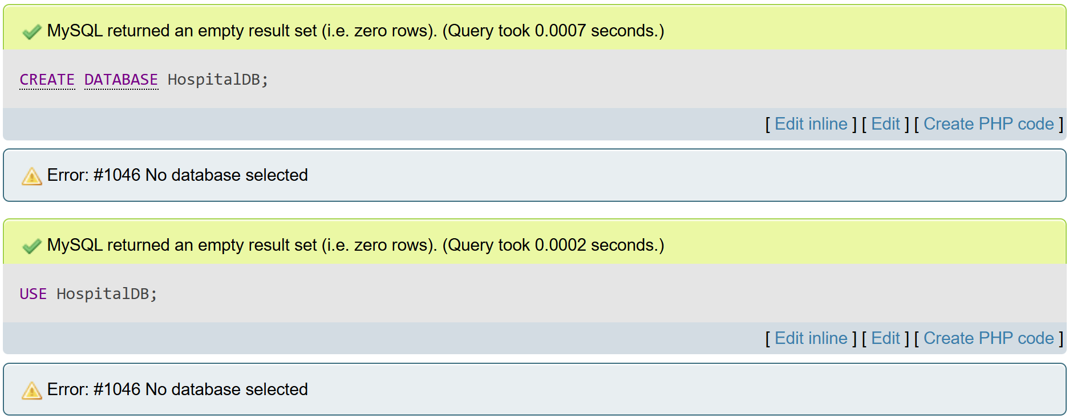

- Create a table
CREATE TABLE Patients (
PatientID INT PRIMARY KEY,
FullName VARCHAR(100),
Age INT CHECK (Age >= 0),
Gender VARCHAR(10),
AdmissionDate DATE NOT NULL
);
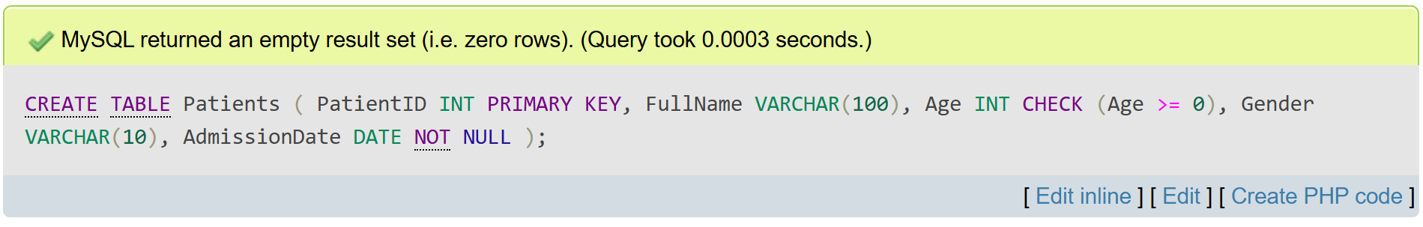

- Show all databases and all tables
SHOW DATABASES;
USE HospitalDB;
SHOW TABLES;
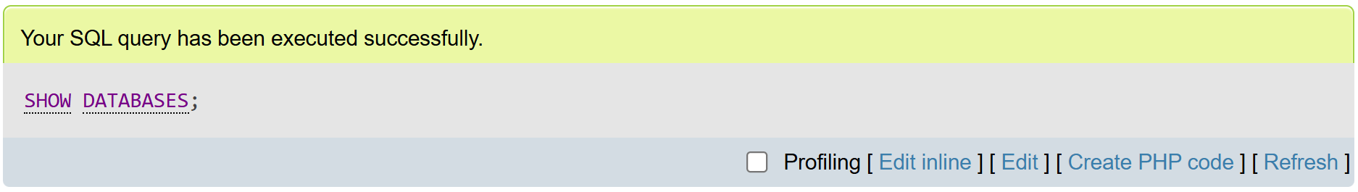
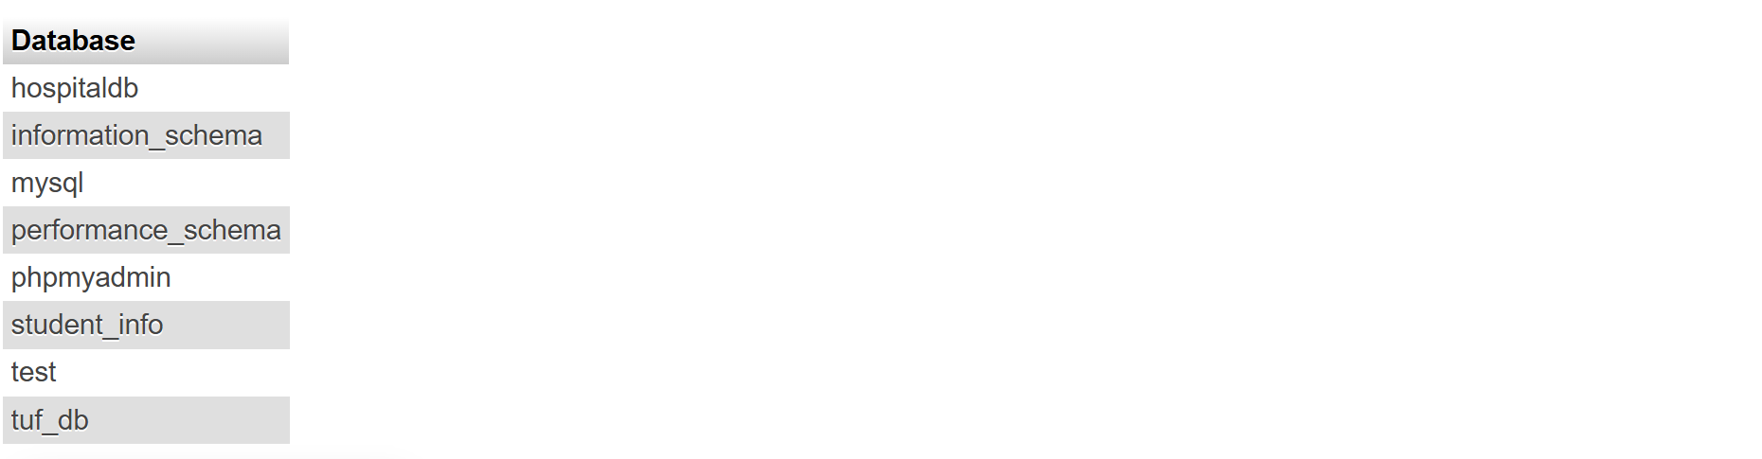
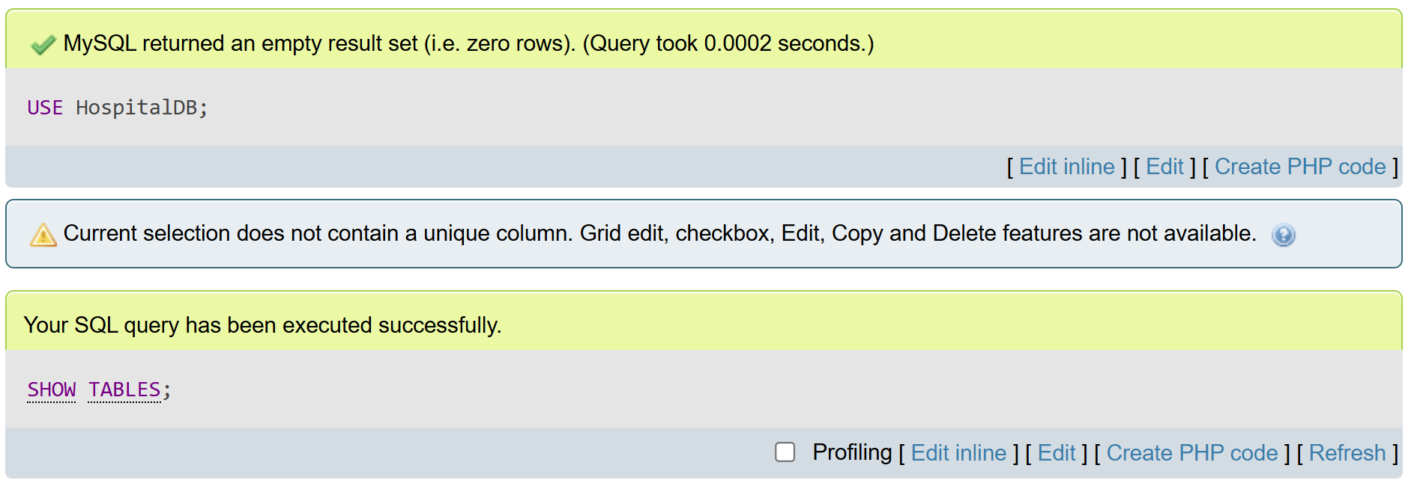

- Add a new column
ALTER TABLE Patients ADD BloodGroup VARCHAR(5);
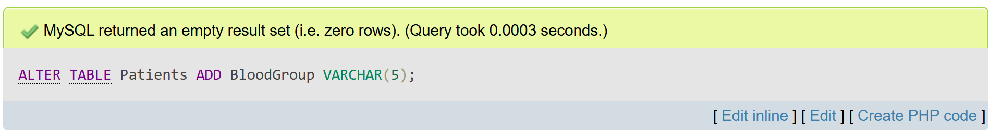

- Insert ten patient records
INSERT INTO Patients (PatientID, FullName, Age, Gender, AdmissionDate, BloodGroup) VALUES
(1, 'Ali Khan', 45, 'Male', '2025-05-10', 'A+'),
(2, 'Sara Malik', 32, 'Female', '2025-05-11', 'B+'),
(3, 'Zain Ahmed', 28, 'Male', '2025-05-09', 'O+'),
(4, 'Areeba Fatima', 22, 'Female', '2025-05-12', 'AB-'),
(5, 'Hassan Raza', 50, 'Male', '2025-05-08', 'A-'),
(6, 'Tariq Mehmood', 60, 'Male', '2025-05-07', 'B-'),
(7, 'Noor Jahan', 18, 'Female', '2025-05-11', 'O-'),
(8, 'Fahad Ali', 35, 'Male', '2025-05-10', 'A+'),
(9, 'Lubna Shah', 27, 'Female', '2025-05-13', 'AB+'),
(10, 'Asad Iqbal', 40, 'Male', '2025-05-06', 'B+');
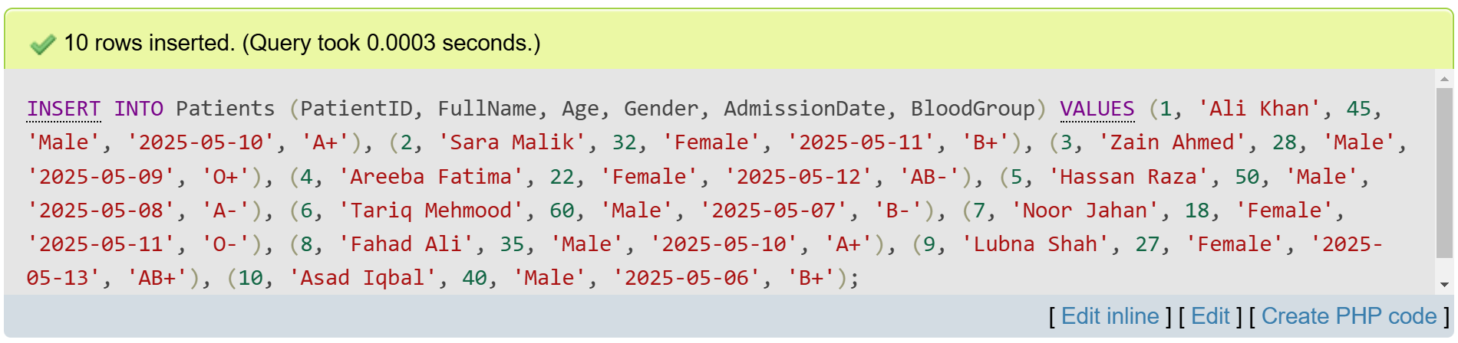

- Update the age of the patient
UPDATE Patients
SET Age = 46
WHERE PatientID = 1;
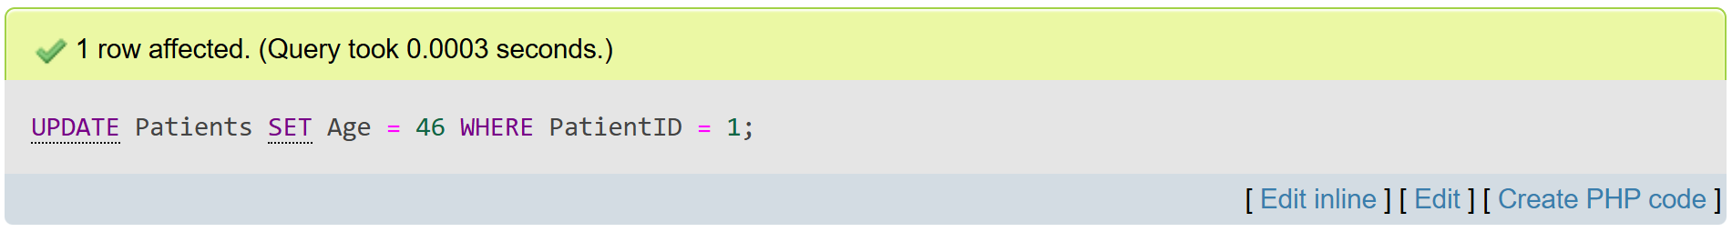

- Delete the record(s) of patients whose gender is 'Female'
DELETE FROM Patients
WHERE Gender = 'Female';
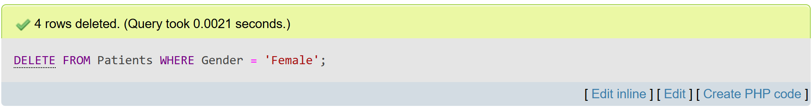

- Select and display all patients older than 25 years
SELECT *
FROM Patients
WHERE Age > 25
ORDER BY AdmissionDate DESC;
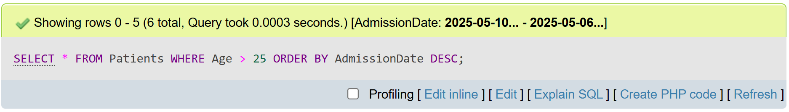
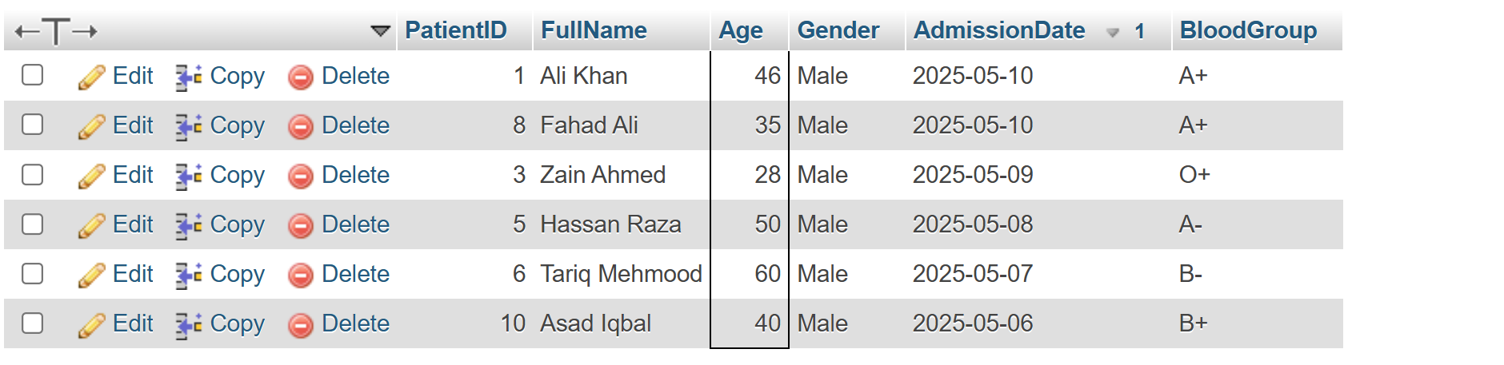

- Drop the entire Patients table
DROP TABLE Patients;
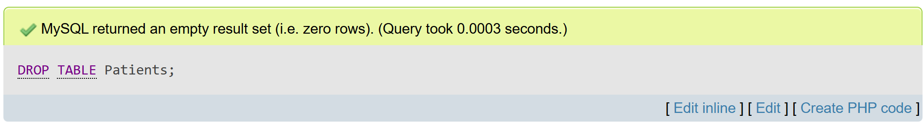
Scenario: University Course System
- Create a database
CREATE DATABASE UniversityDB;
USE UniversityDB;
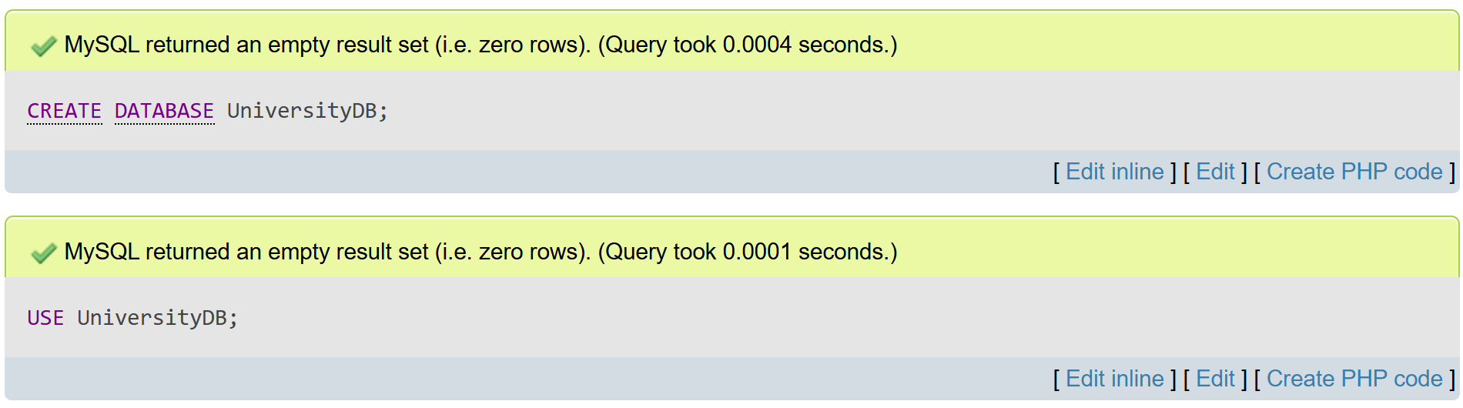

- Create a table
CREATE TABLE Courses (
CourseID INT PRIMARY KEY,
CourseName VARCHAR(100),
Instructor VARCHAR(100),
Credits INT CHECK (Credits BETWEEN 1 AND 6)
);
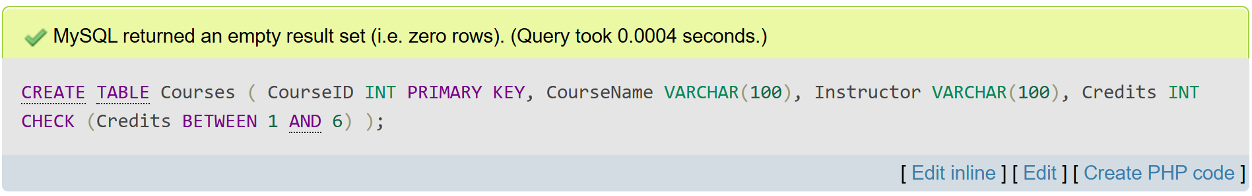

- Show all databases and show tables
SHOW DATABASES;
USE UniversityDB;
SHOW TABLES;
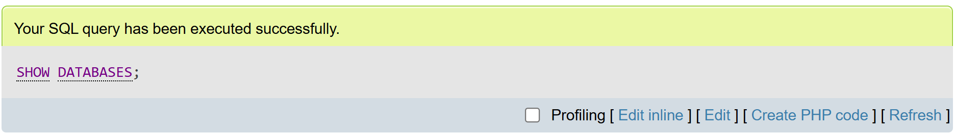
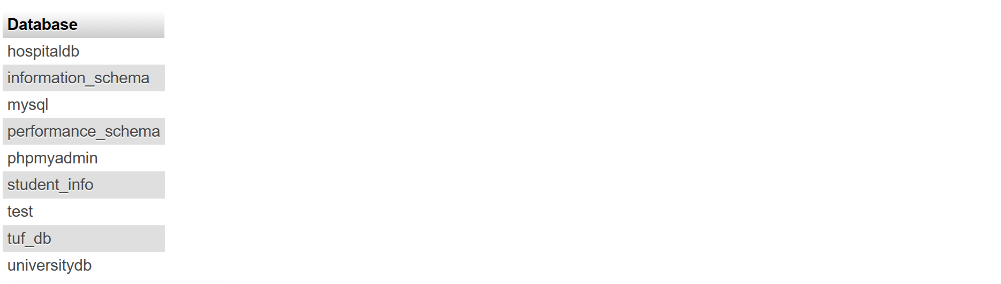

- Add a new column
ALTER TABLE Courses ADD Department VARCHAR(100);
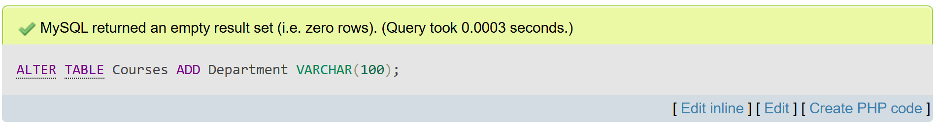

- Insert ten course records
INSERT INTO Courses (CourseID, CourseName, Instructor, Credits, Department) VALUES
(101, 'Data Structures', 'Dr. Smith', 3, 'Computer Science'),
(102, 'Calculus', 'Prof. Khan', 4, 'Mathematics'),
(103, 'Operating Systems', 'Dr. Lee', 3, 'Computer Science'),
(104, 'Microeconomics', 'Dr. Fatima', 2, 'Economics'),
(105, 'Database Systems', 'Dr. Alice', 3, 'Computer Science'),
(106, 'Linear Algebra', 'Prof. Ahmed', 4, 'Mathematics'),
(107, 'Networking', 'Dr. Imran', 3, 'Computer Science'),
(108, 'Statistics', 'Dr. Sana', 2, 'Mathematics'),
(109, 'Artificial Intelligence', 'Dr. Yasir', 5, 'Computer Science'),
(110, 'Psychology 101', 'Dr. Maria', 3, 'Psychology');
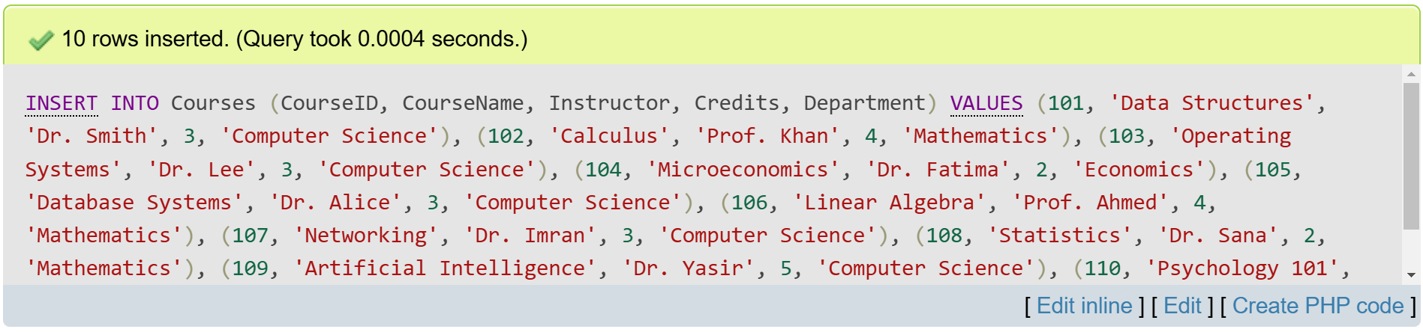
- Update the instructor’s name for the course with CourseID = 101
UPDATE Courses
SET Instructor = 'Dr. Alice Allen'
WHERE CourseID = 101;
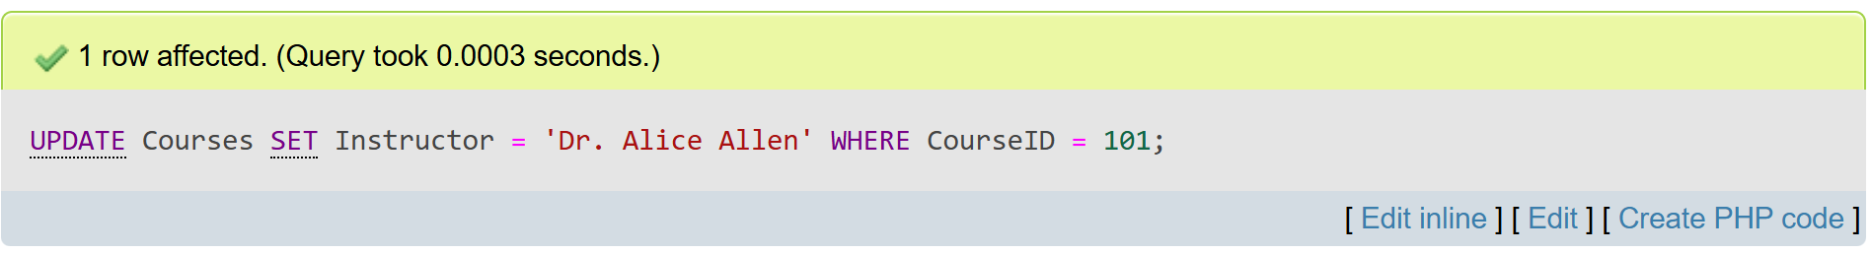

- Delete the course record where the credits are equal to 4
DELETE FROM Courses
WHERE Credits = 4;
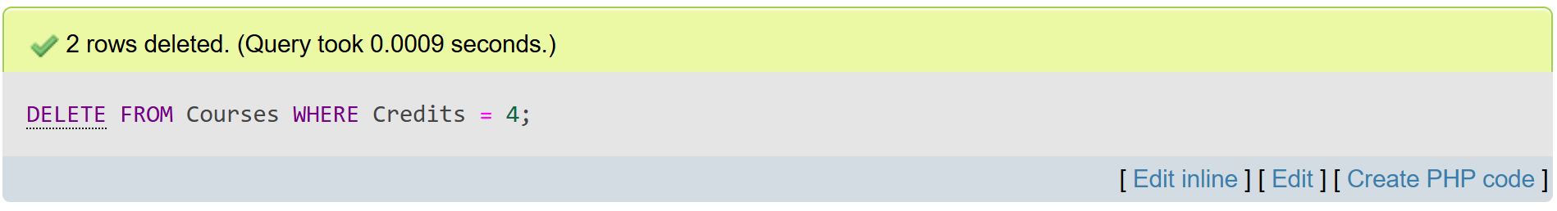

- Select and display all courses in the 'Computer Science' department, ordered by course name
SELECT *
FROM Courses
WHERE Department = 'Computer Science'
ORDER BY CourseName ASC;
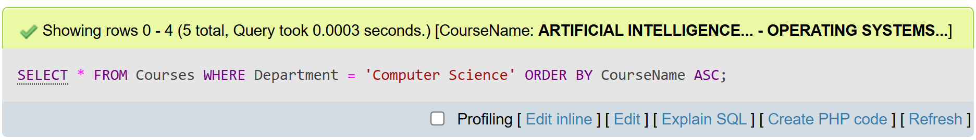
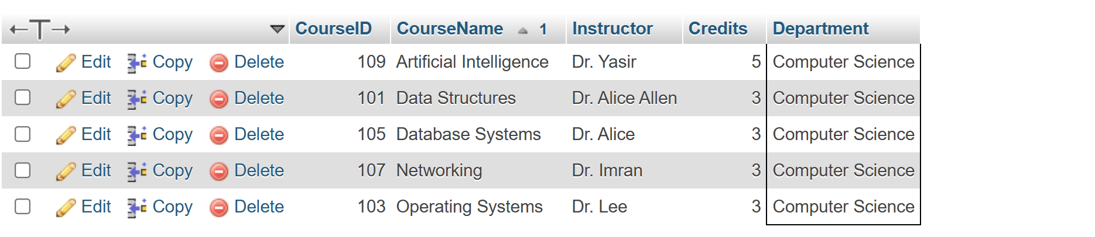

- Drop the Courses table
DROP TABLE Courses;
